First create simple html page

As index.html

Write some message using tags.

index.html

<!DOCTYPE html>

<html lang="en">

<head>

    <meta charset="UTF-8">

    <meta name="viewport" content="width=device-width, initial-scale=1.0">

    <title>Document</title>

</head>

<body>

    <h2>Welcome to simple web page deploy using docker with jenkin in ec2 instnace</h2>

</body>

</html>

now we will create the Dockerfile

git init

git add .

git commit -m “initial project ready”

git remote add origin URL (URL remote repository URL)

git push -u origin main/master

after push please check this code in your remote repository.

Please login to AWS account.

Then search EC2 instance option

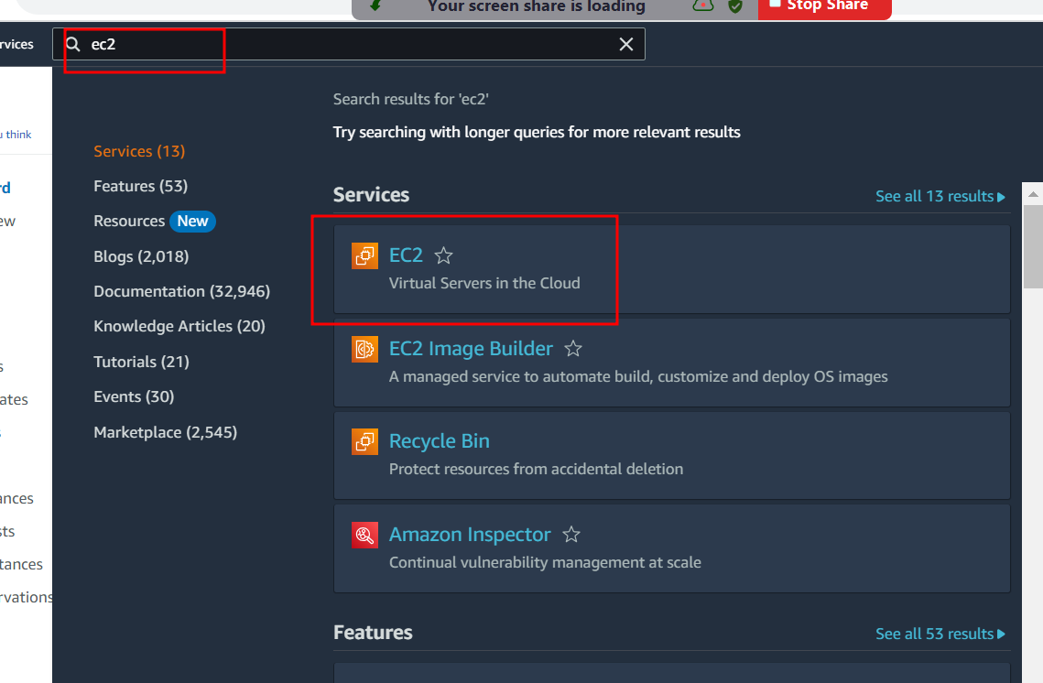

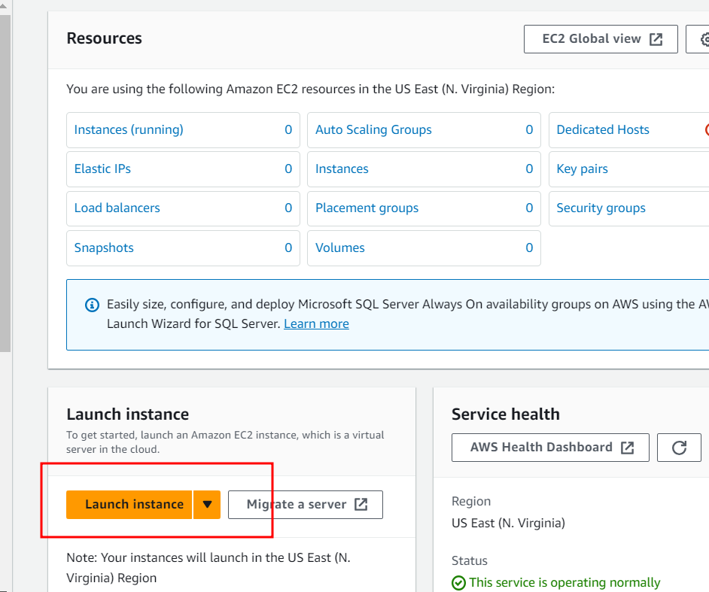

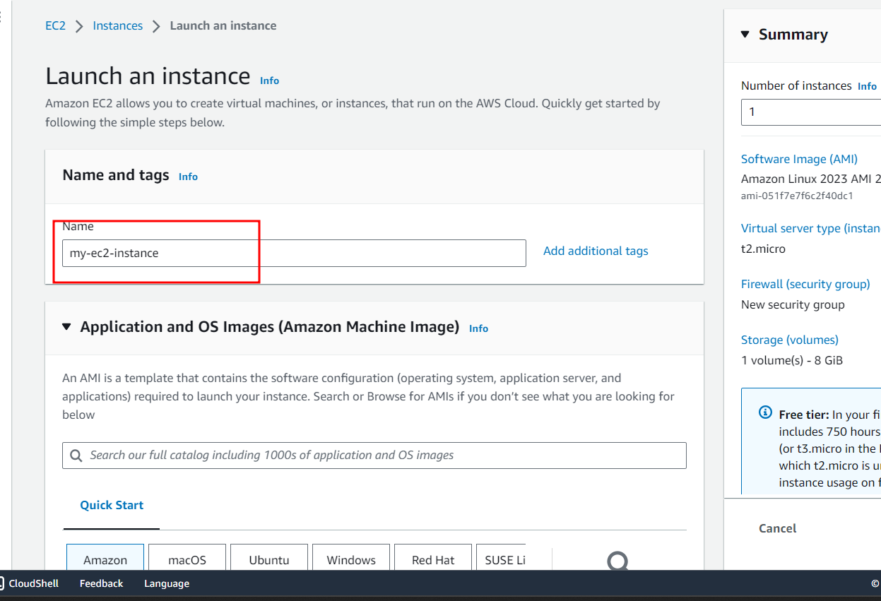

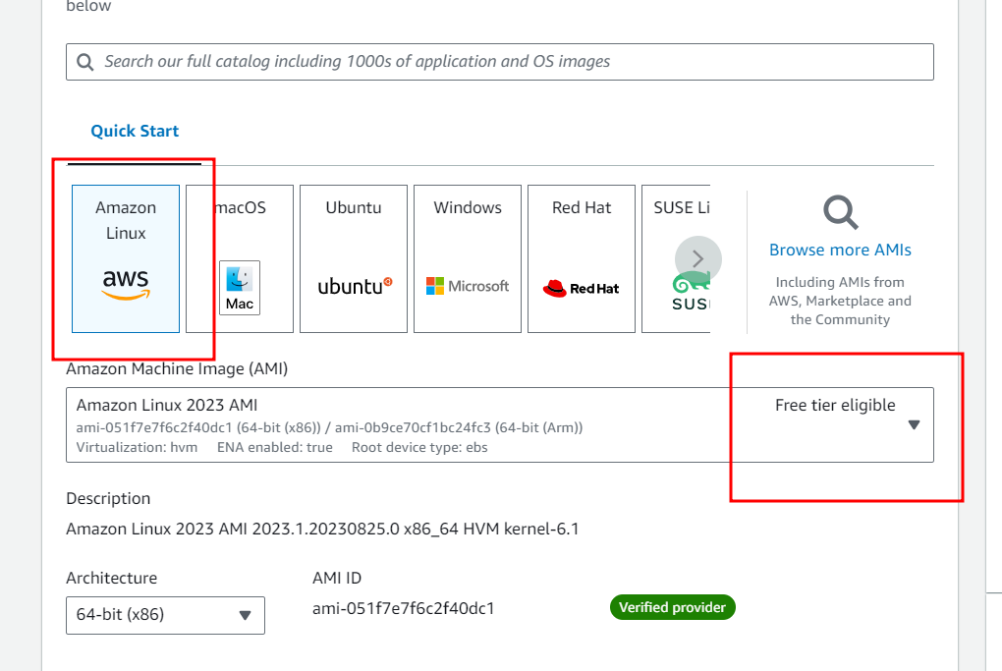

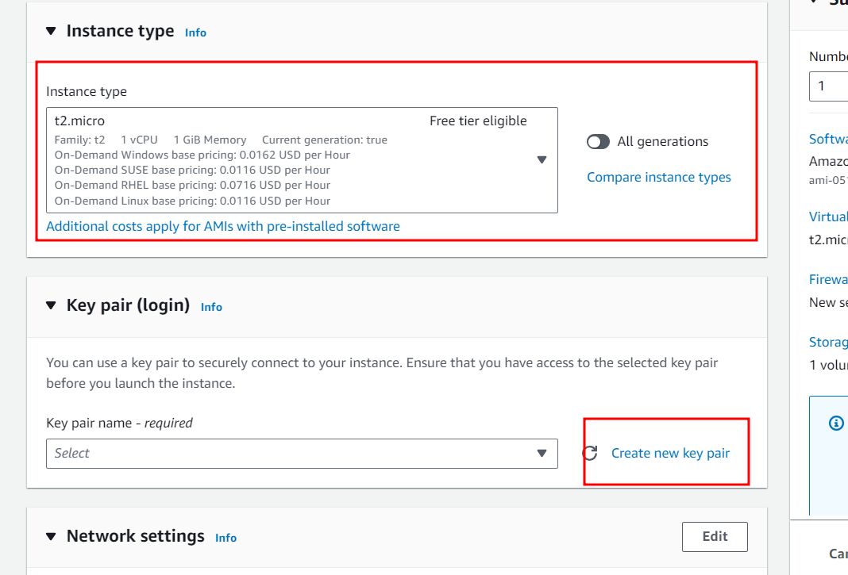

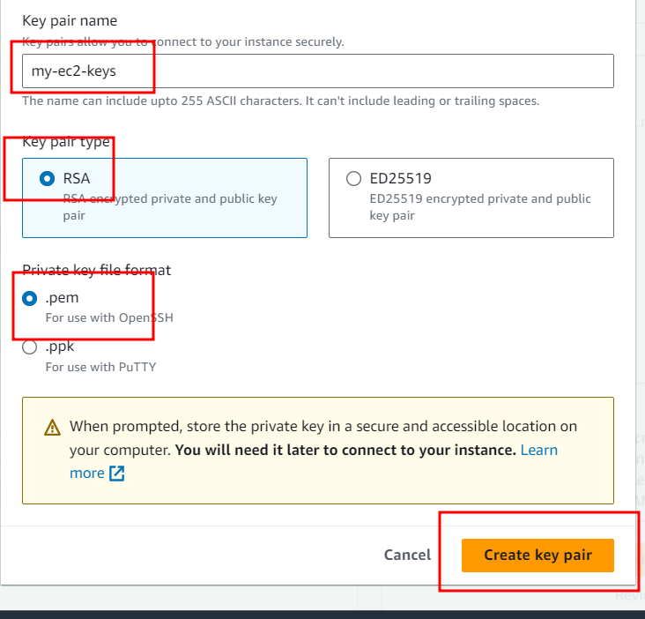

Download key and remember key path.

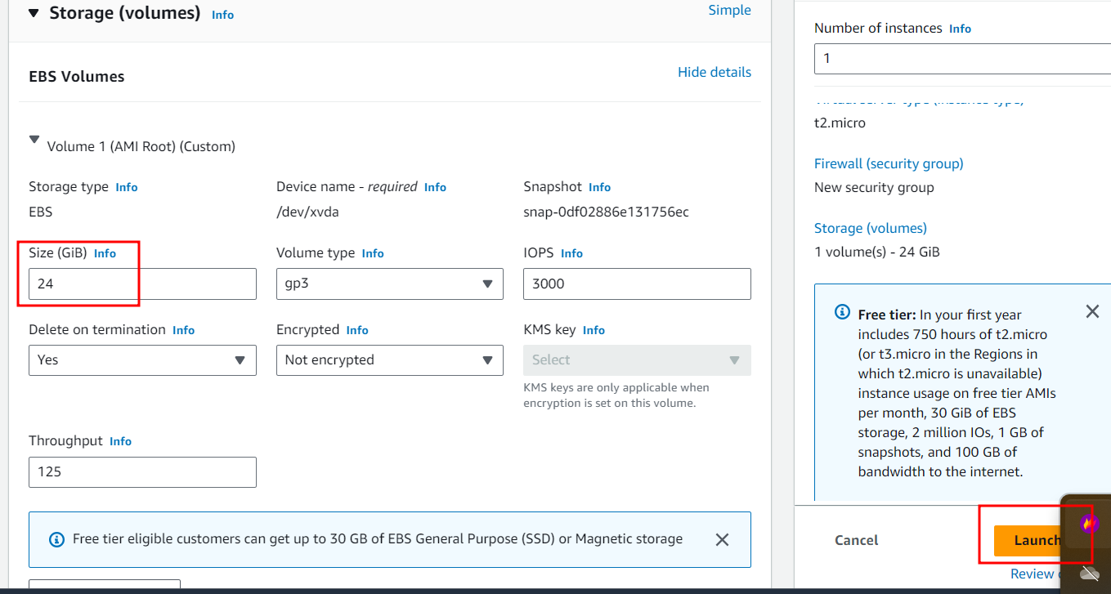

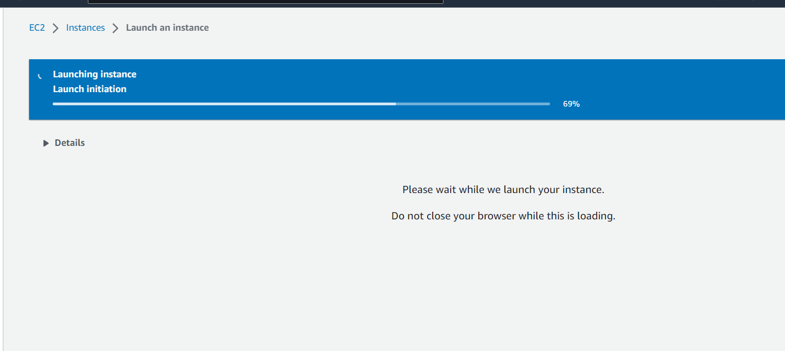

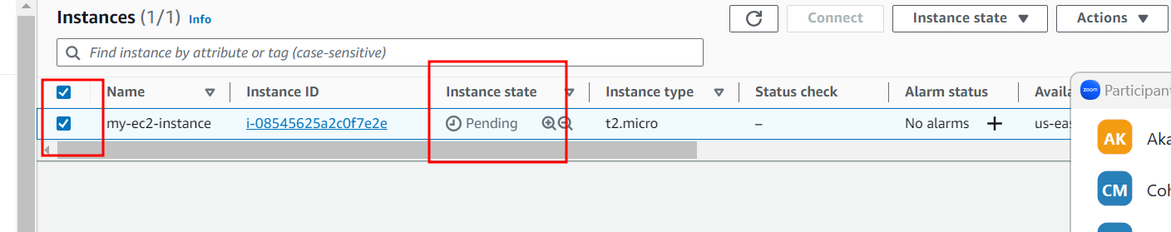

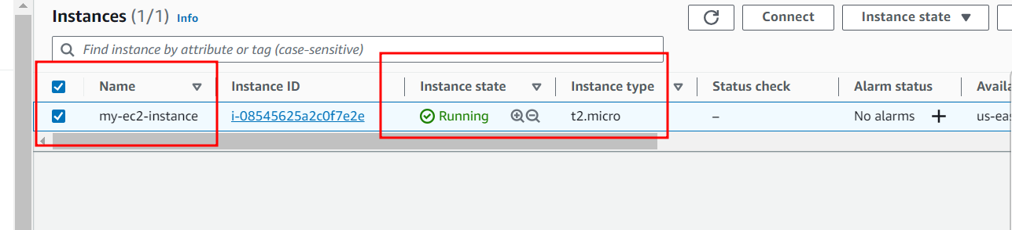

Now in EC2 instance we will open all port

3306 🡪 mysql database

9090🡪 spring boot

80🡪 angular with nginx server

8080🡪 Jenkin

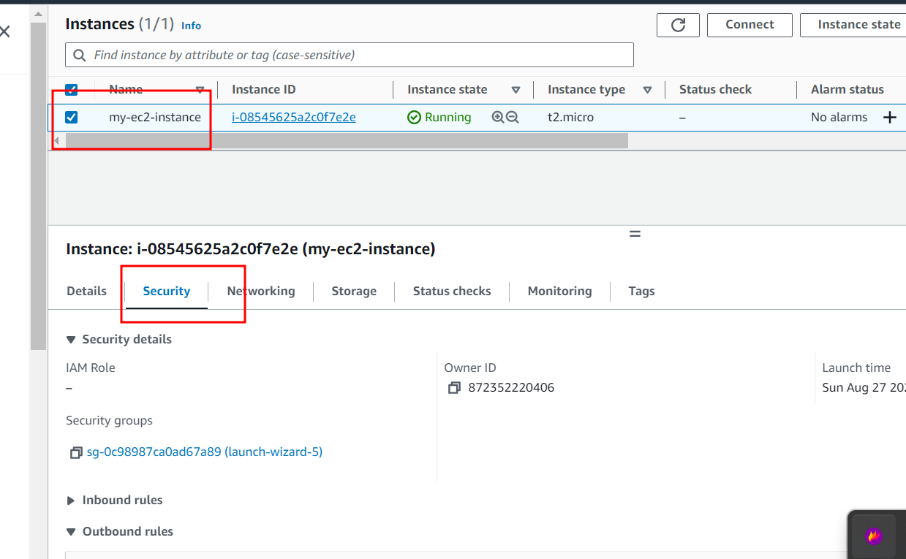

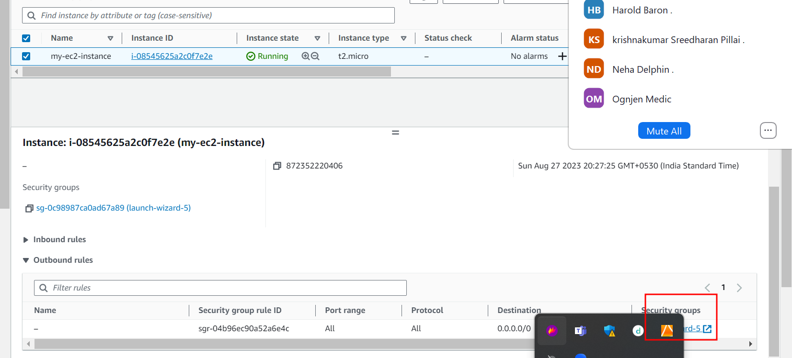

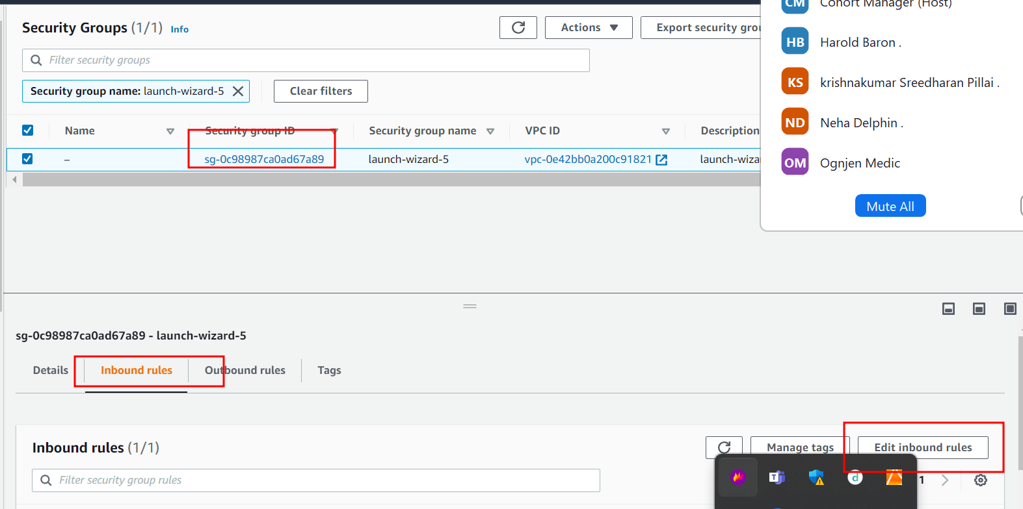

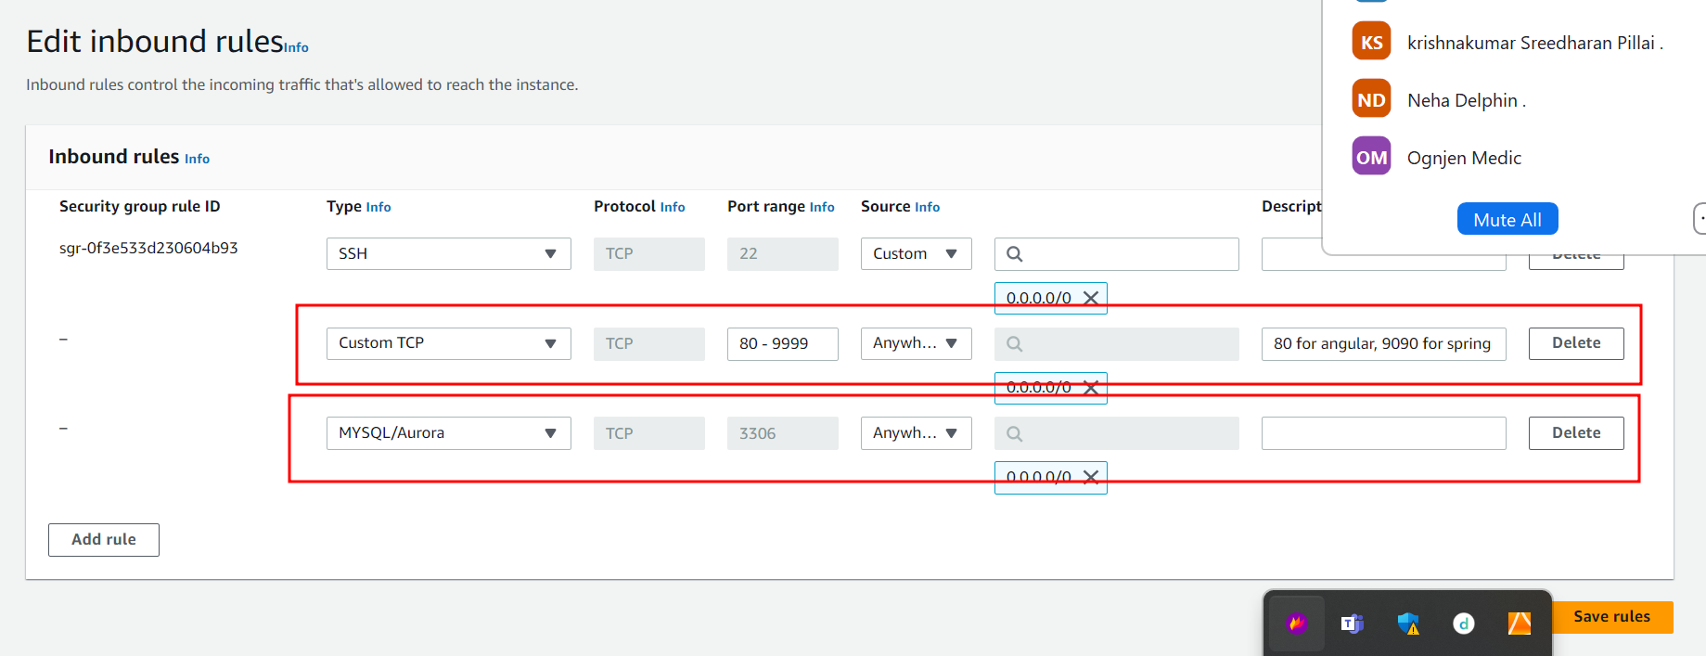

Close security wizard tab.

Now we are going to connect EC2 instance using terminal

Ie git bash (for window user)

Non window user (normal terminal)

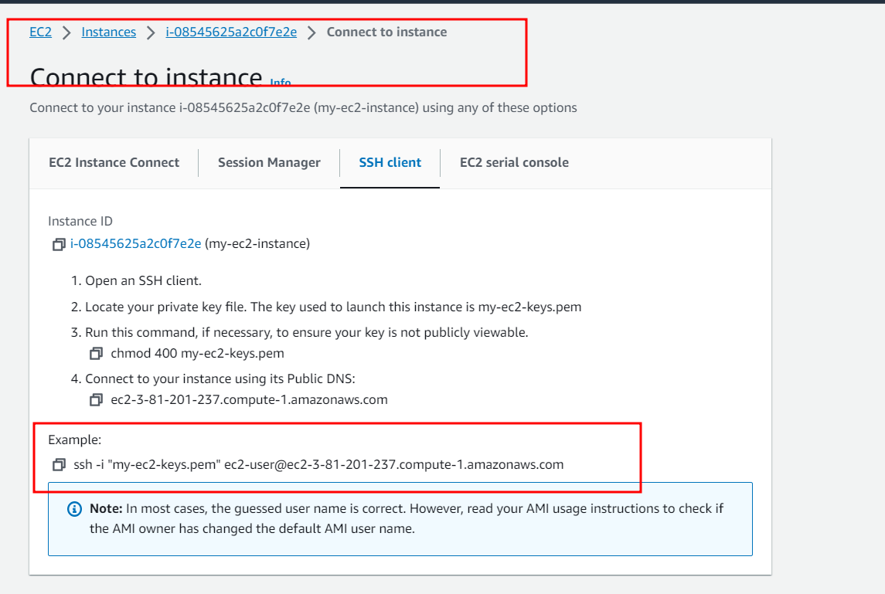

Please copy example ssh client commands

Then open git bash or normal terminal (but make sure .pem key file present int that location).

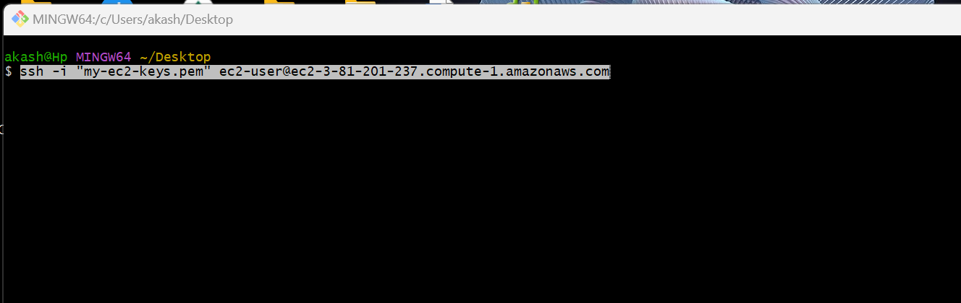

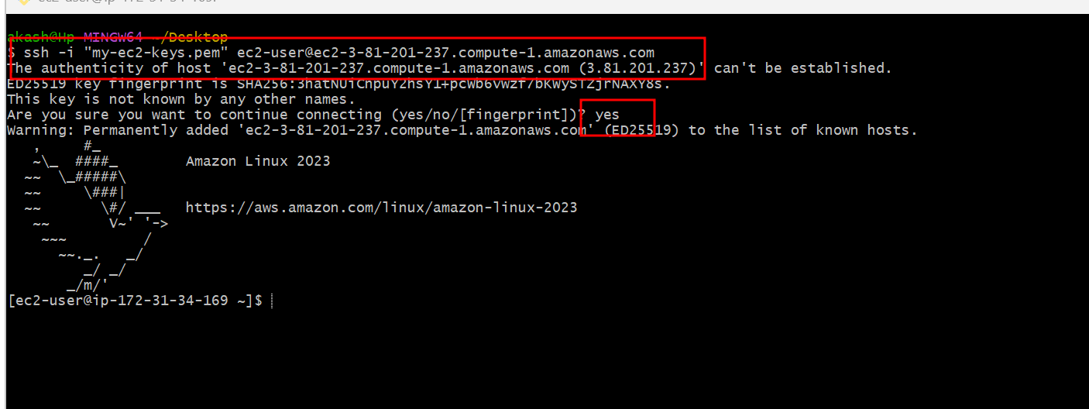

Now we need to install all required software in EC2 instance.

Git install

sudo yum install git -y

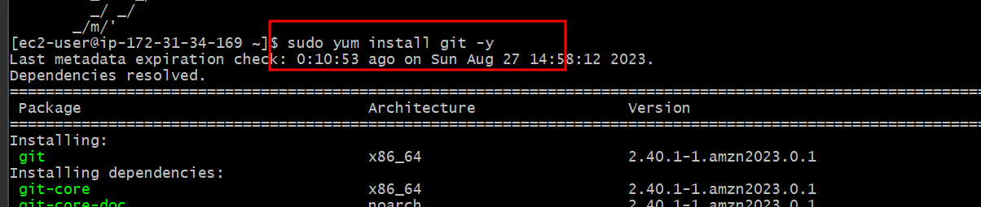

Java install

sudo yum install java-11

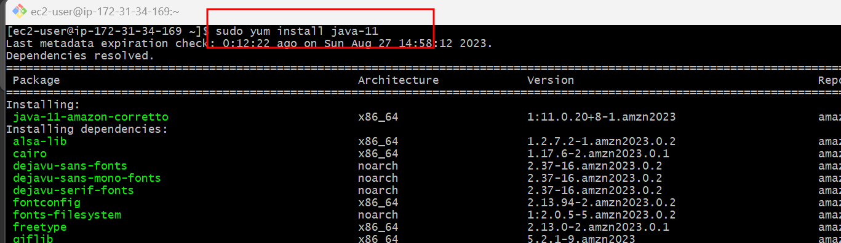

**Jenkin install**

sudo wget -O /etc/yum.repos.d/jenkins.repo <https://pkg.jenkins.io/redhat/jenkins.repo>

sudo rpm --import <https://pkg.jenkins.io/redhat-stable/jenkins.io.key>

sudo yum install Jenkins

after installation we need to start the Jenkin

sudo service jenkins start this command to start

sudo systemctl status Jenkins this is use to check the status

to exit that flow please type cntr + c twice

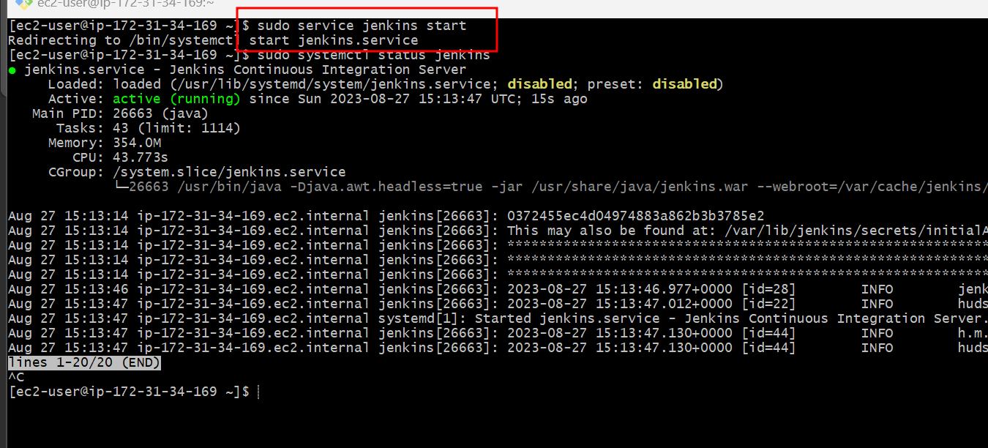

Docker install

sudo yum install docker

sudo service docker start

sudo docker –version

Docker compose

sudo curl -L https://github.com/docker/compose/releases/download/1.22.0/docker-compose-$(uname -s)-$(uname -m) -o /usr/local/bin/docker-compose

sudo chmod +x /usr/local/bin/docker-compose

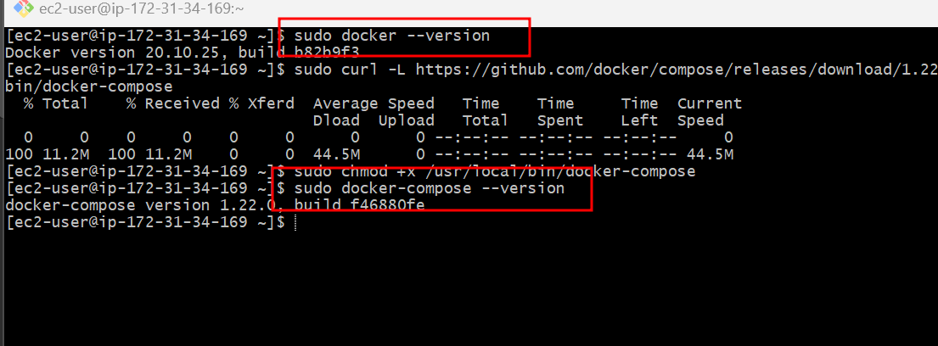

Provide permission to run docker and docker compose command in Jenkin environment.

sudo usermod -a -G docker jenkins

sudo usermod -a -G docker ec2-user (ec2-user is user name of instance )

sudo chmod 777 /var/run/docker.sock

after this please restart Jenkins or ec2 instance.

Please sudo reboot command restart ec2 instance to update all changes.

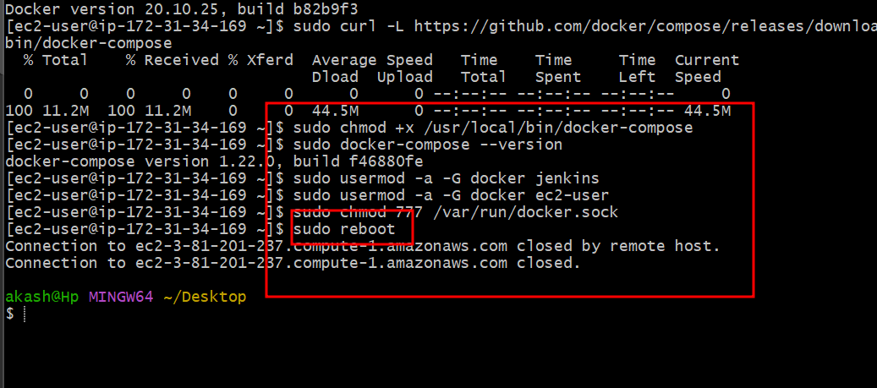

Wait for few minutes to start ec2 instance.

After reboot please connect to ec2 instance using ssh client command

Then start Jenkin service once again using command as

sudo service jenkins start

after start Jenkin please open ec2 dashboard then check Ec2 instance IP Address

hit on browser as <http://ipaddress:8080>

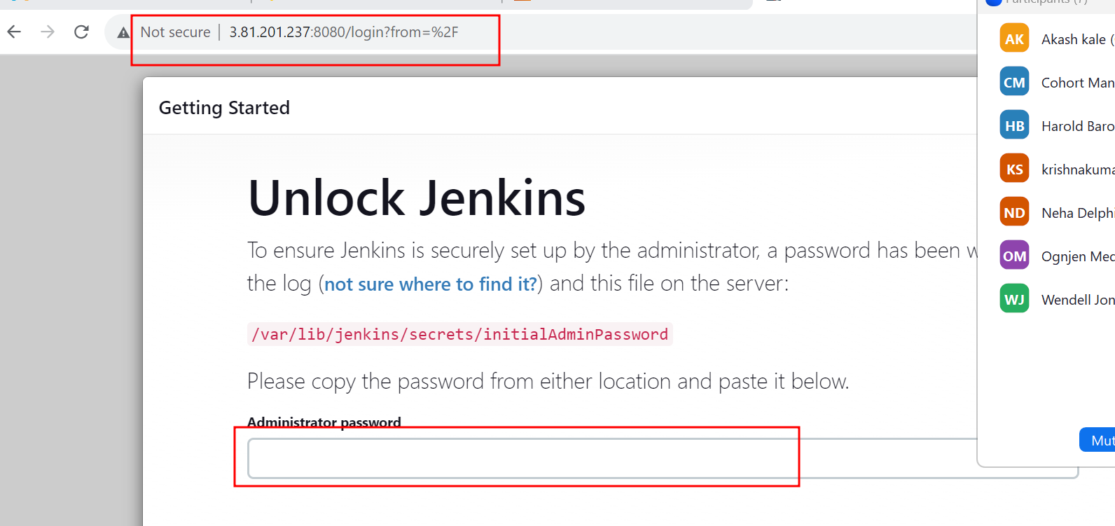

At the first time it will ask random password.

To get the password please write the command in ec2 instance as

sudo cat /var/lib/jenkins/secrets/initialAdminPassword

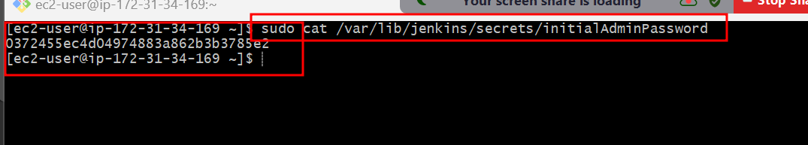

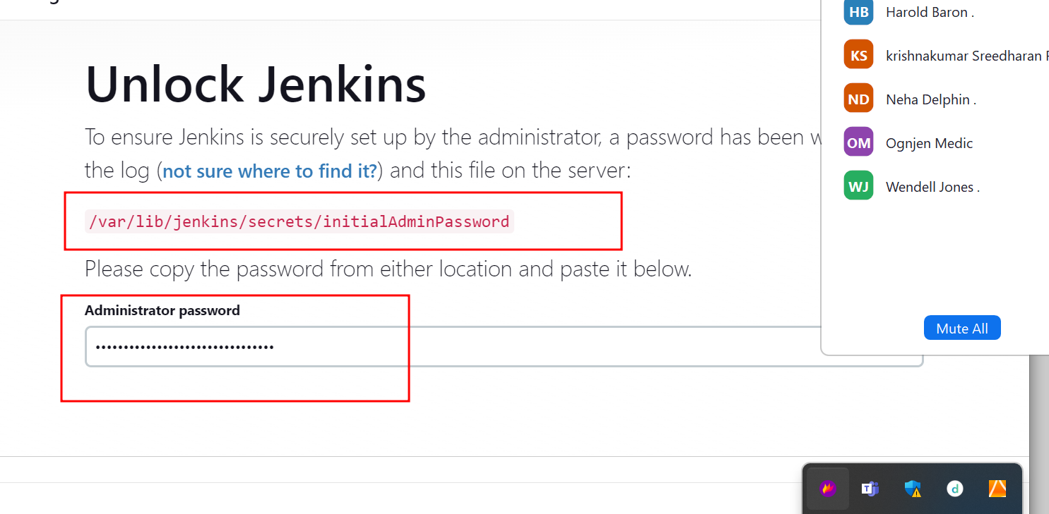

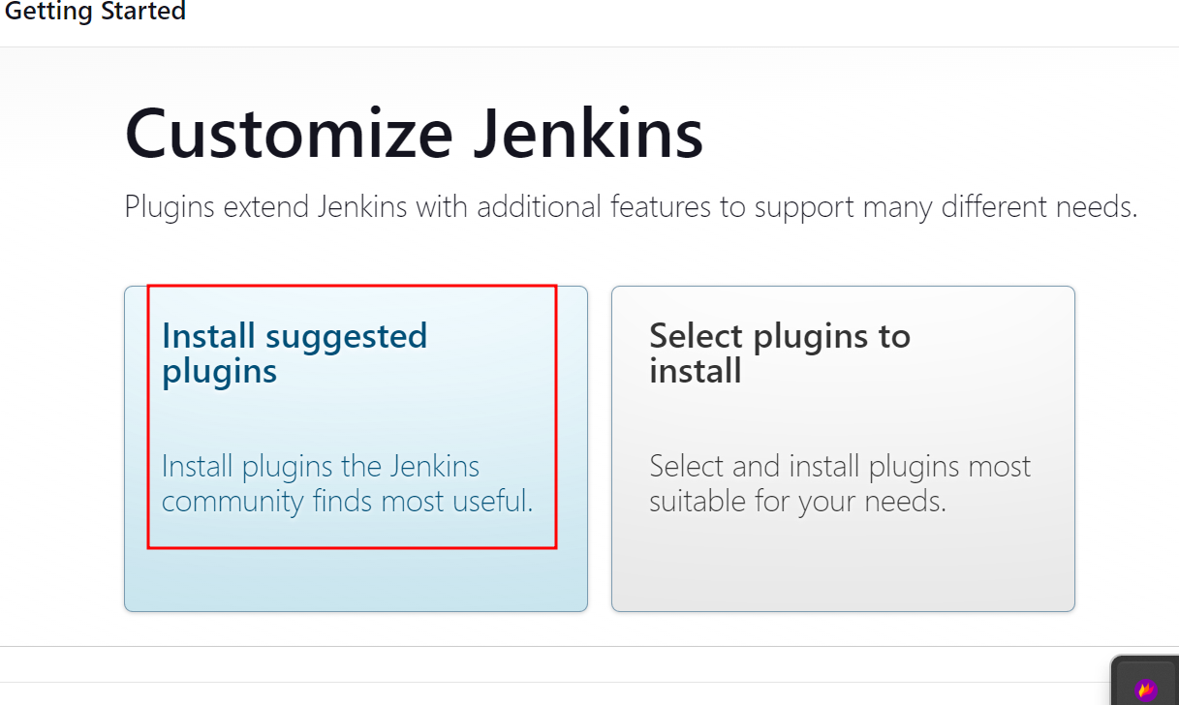

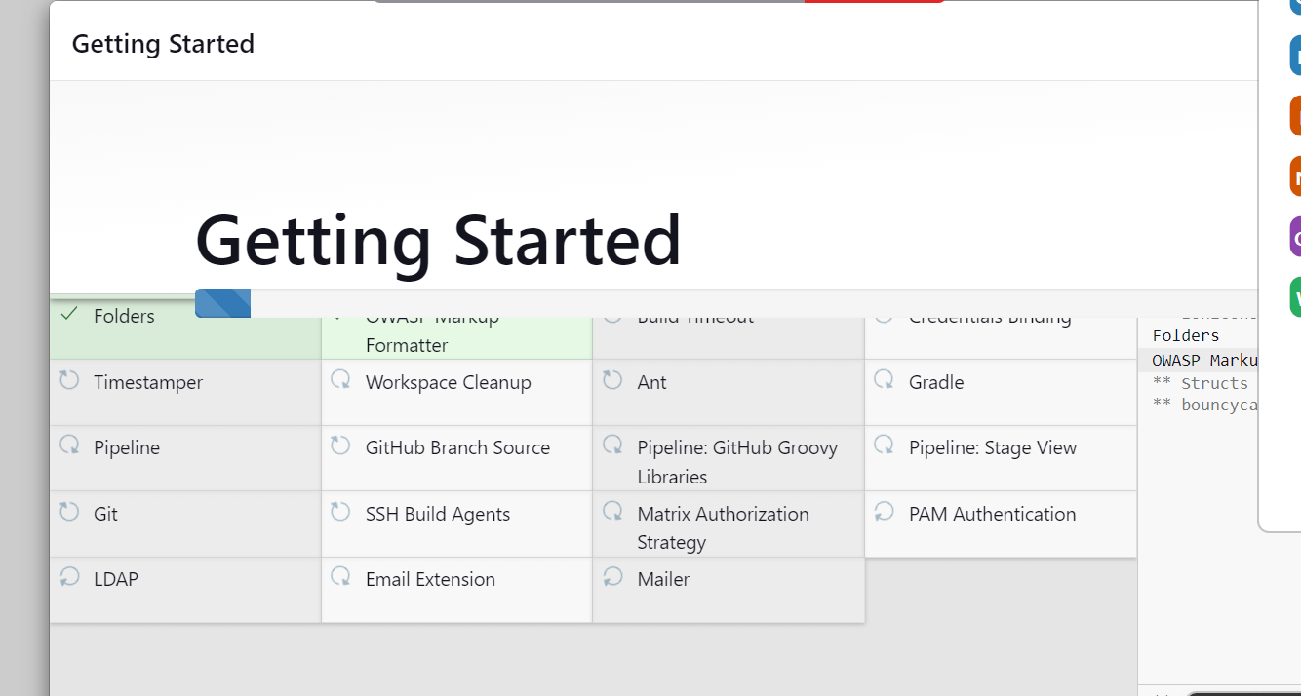

Then create your own account.

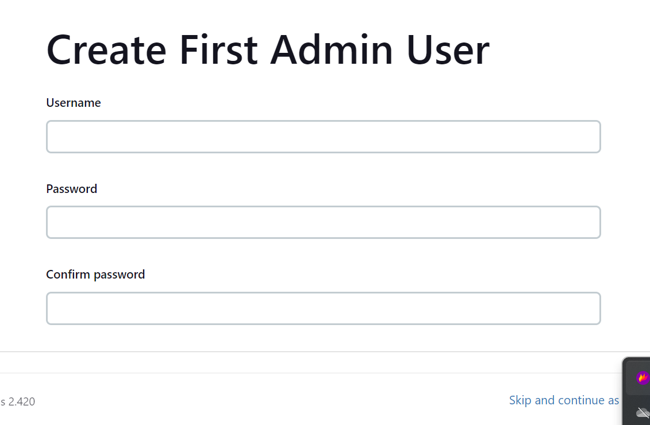

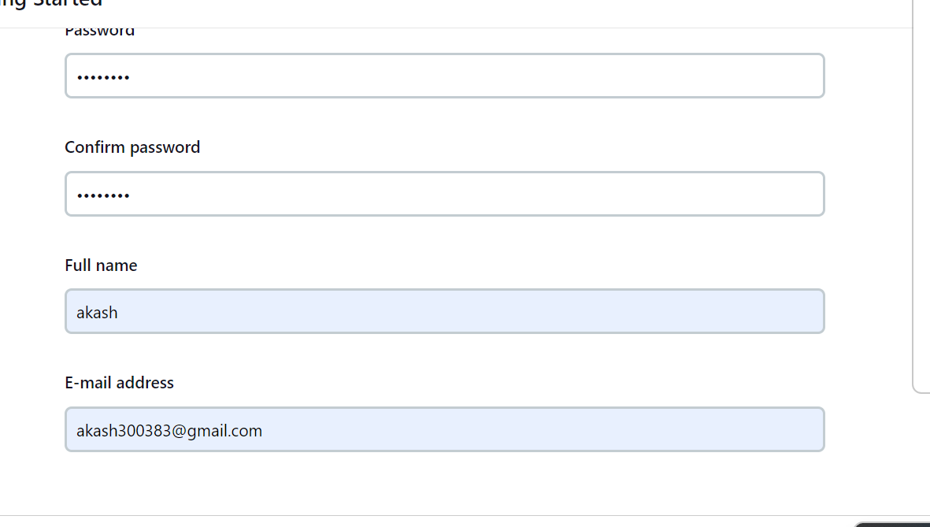

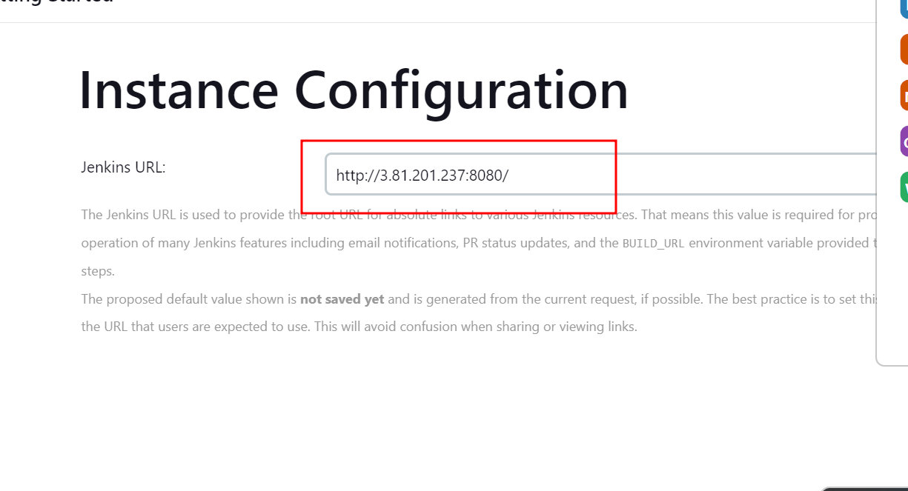

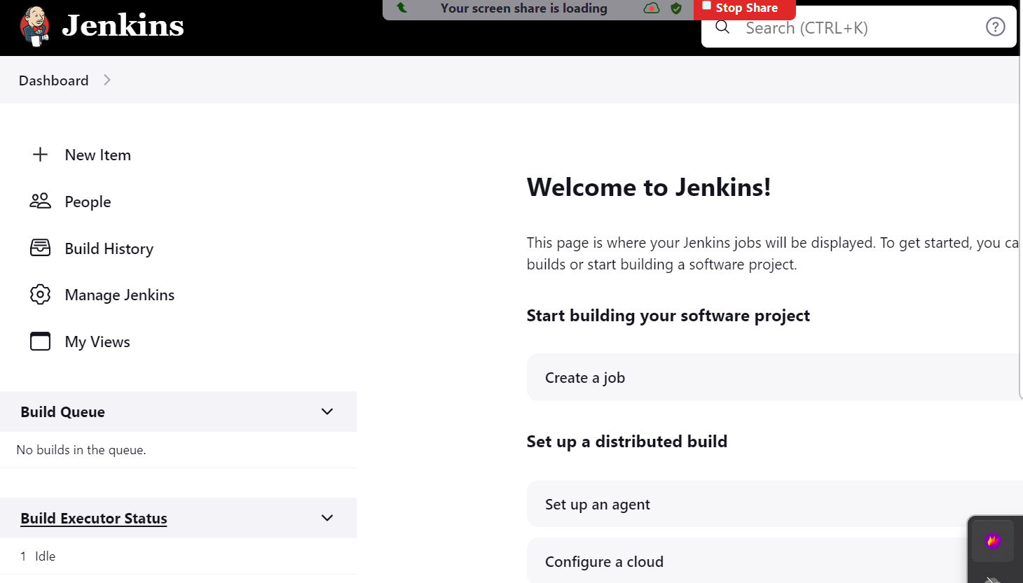

In angular project inside service class we need to write the IPAddress of EC2 instance to call frontend to backend.

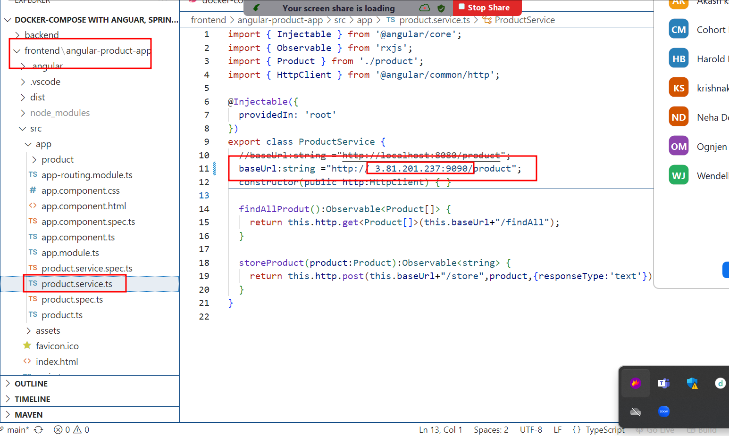

Please write your ec2 instance id address in every service file as of now.

Once we do any changes in frontend or backend we need re-build in local machine.

And we need to push this code once again in git hub repository.

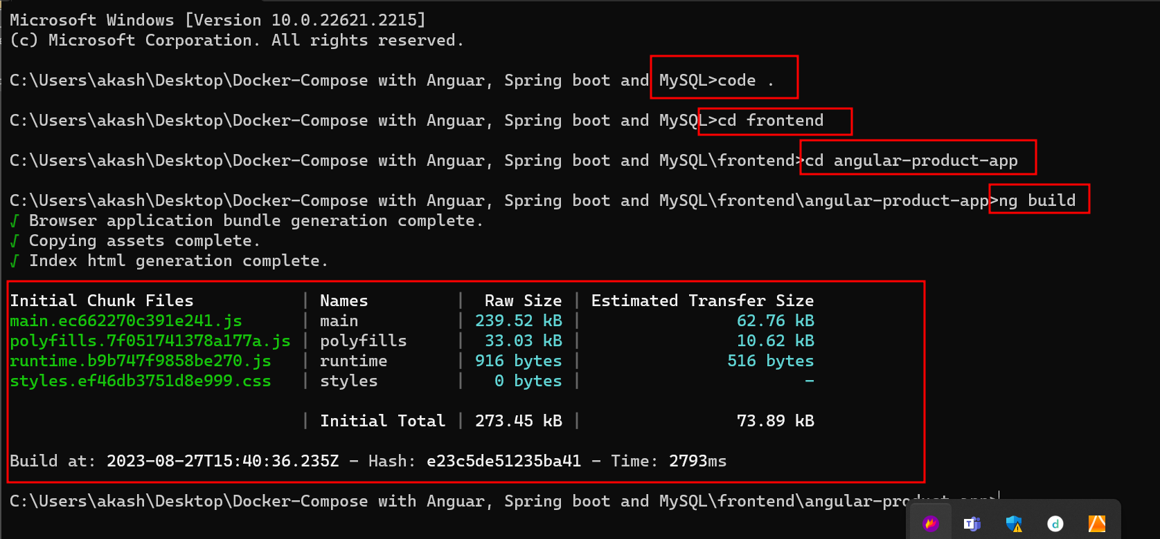

This come to main folder to push the code in git hub account.

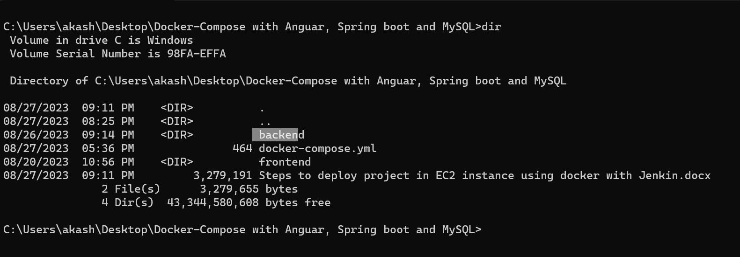

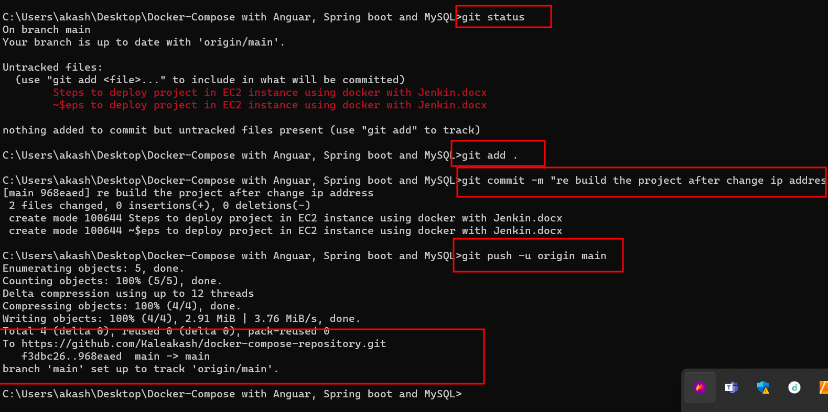

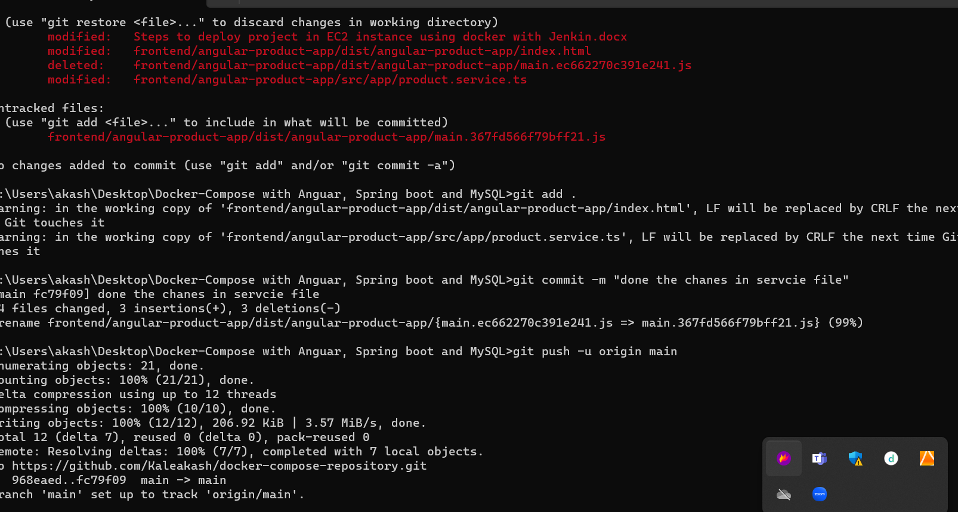

Now in Jenkin dashboard we will create job.

We will create job to check java –version, git version, docker version and docker-compose version

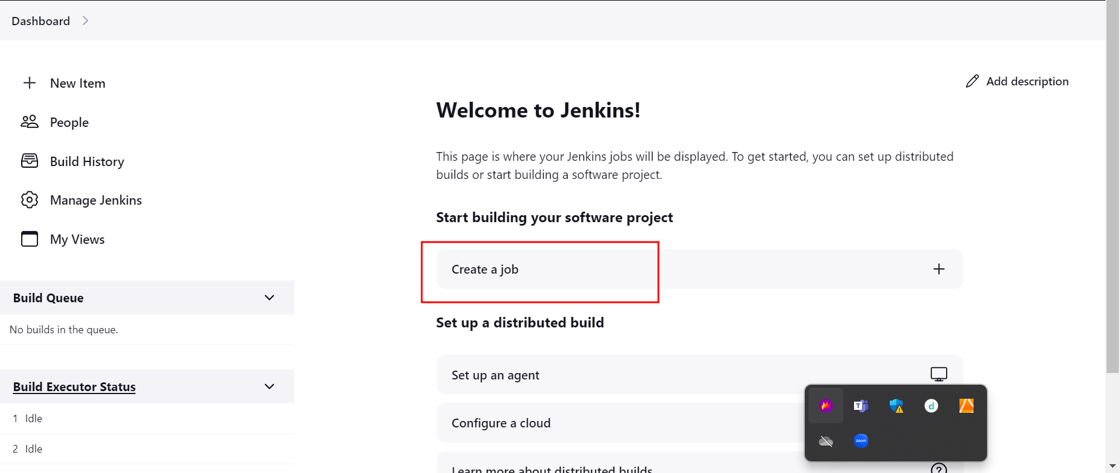

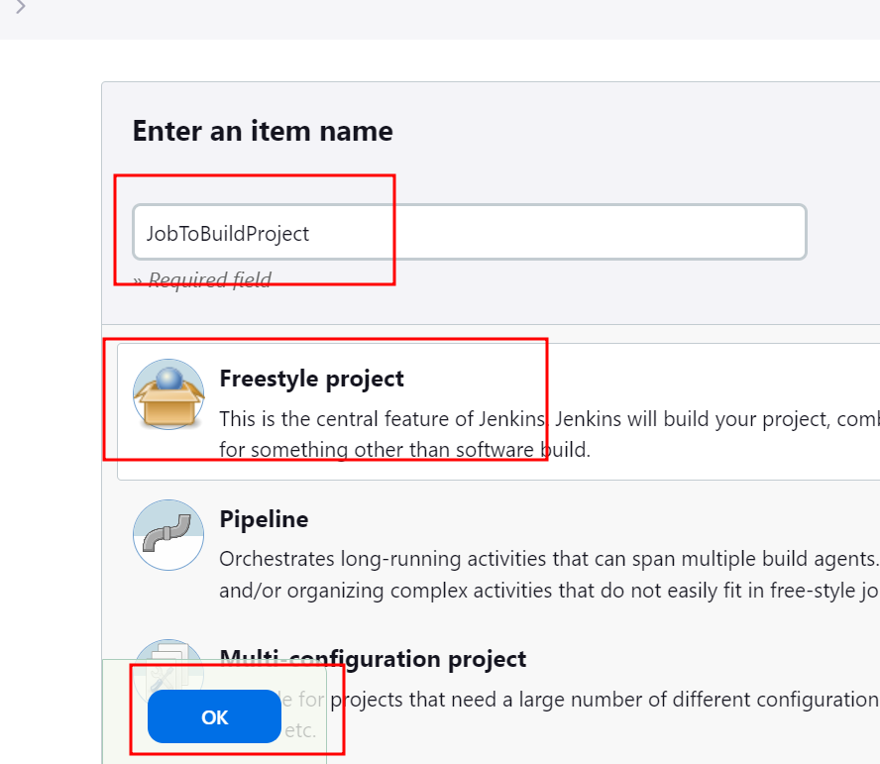

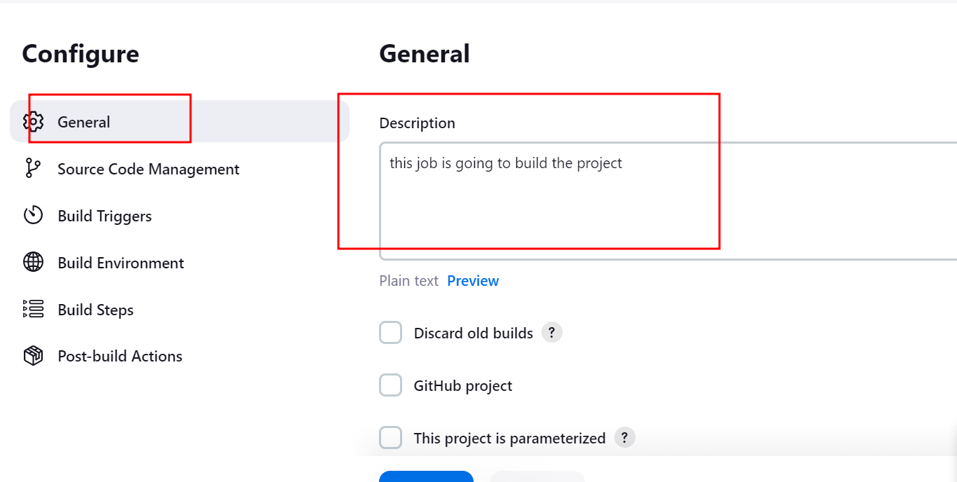

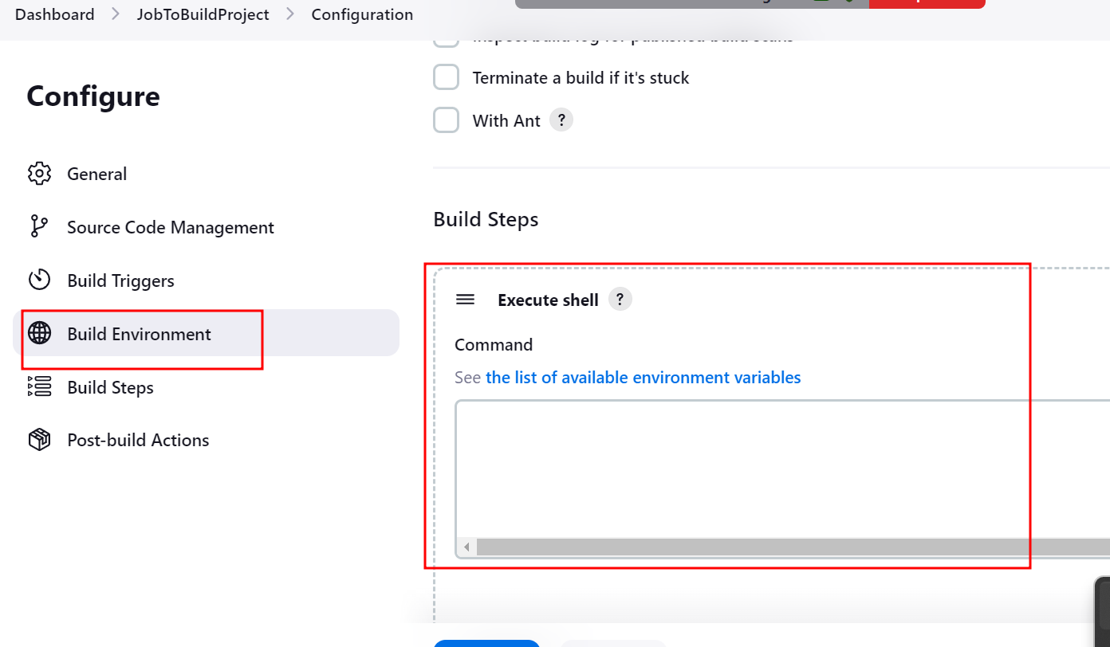

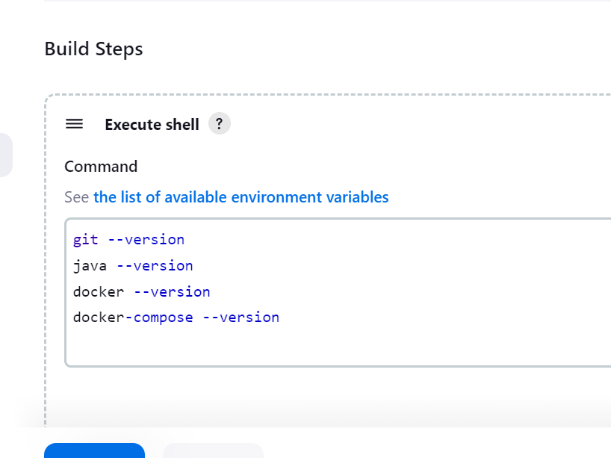

Click on apply and save

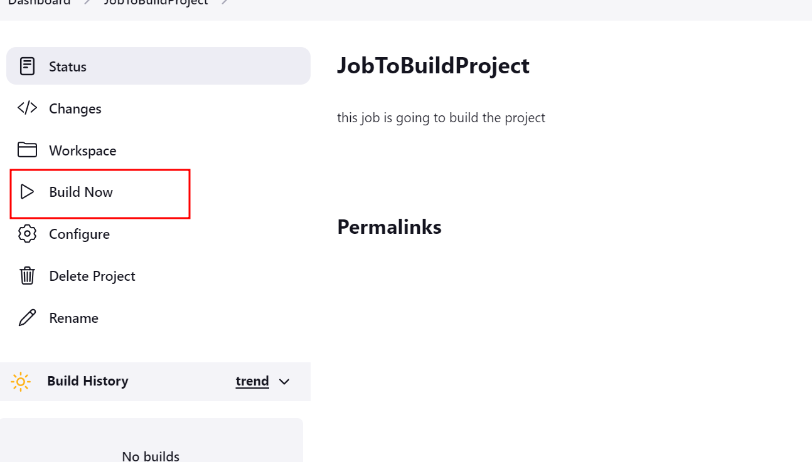

Then click on build button

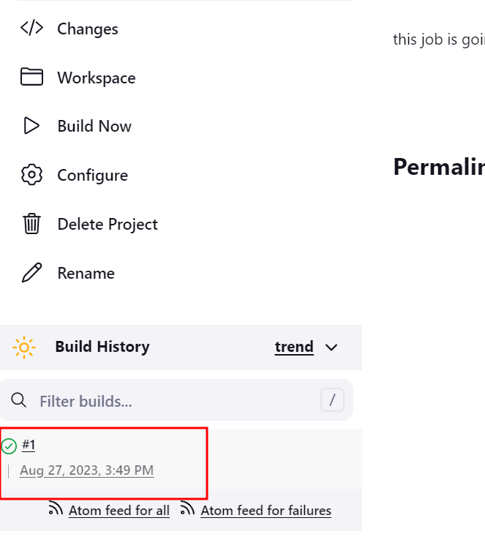

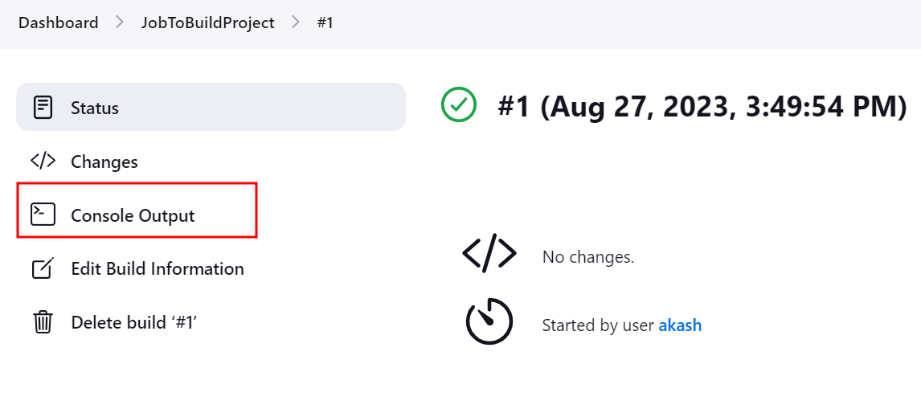

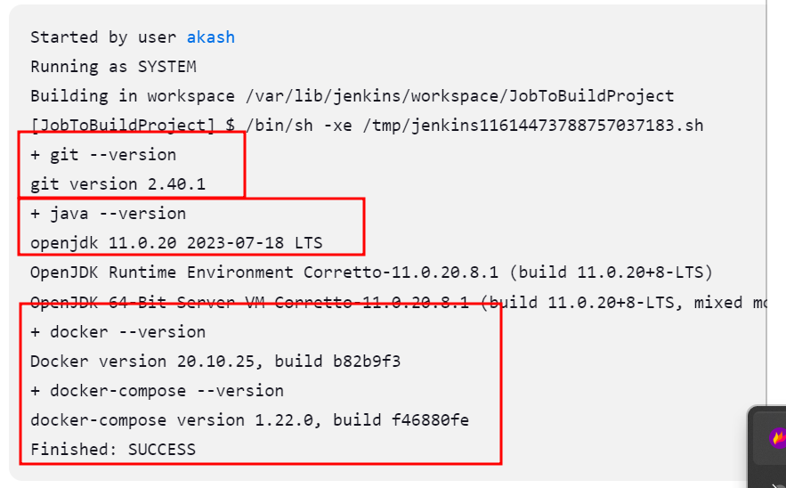

Now in same job we will pull the project from git

Please check on dashboard

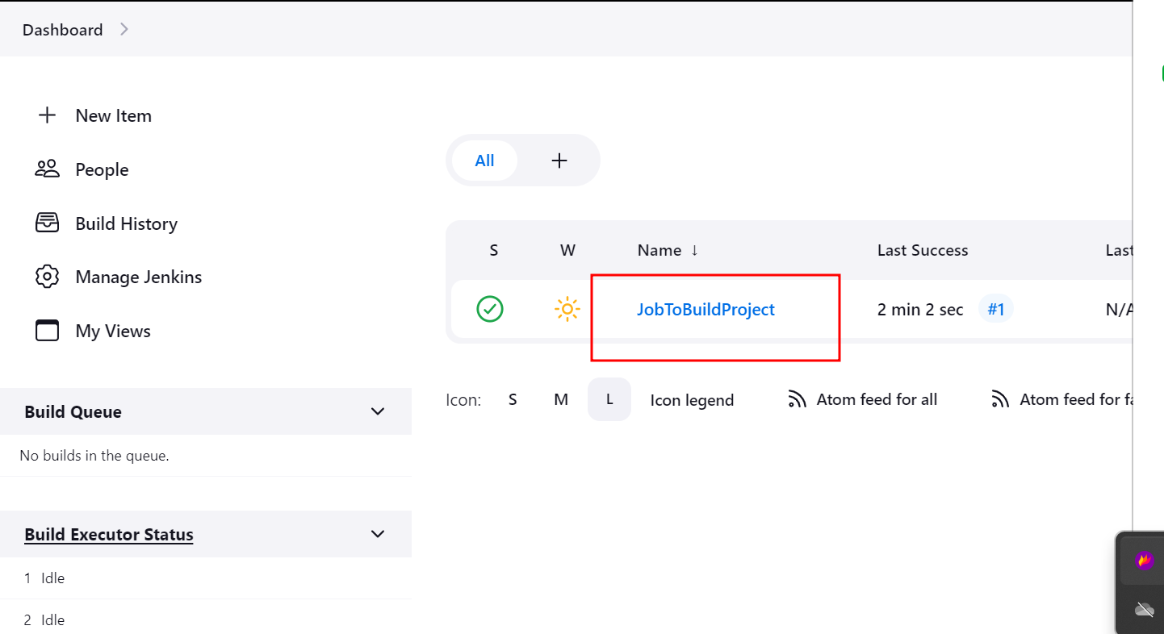

Right click on job and select

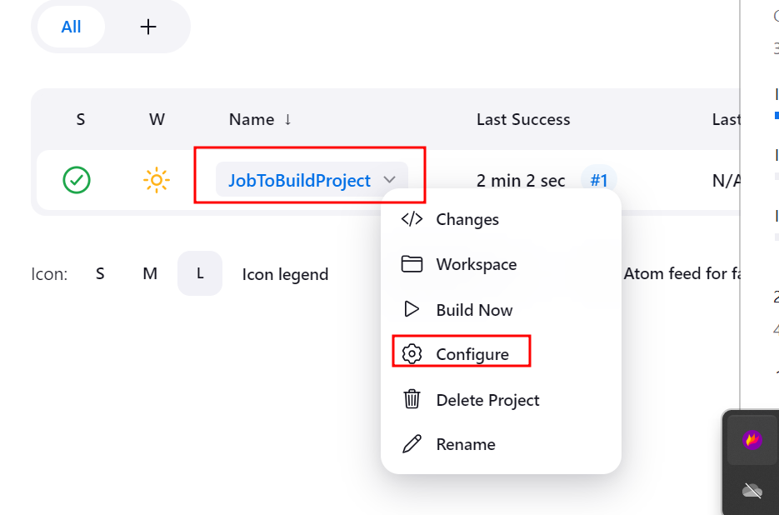

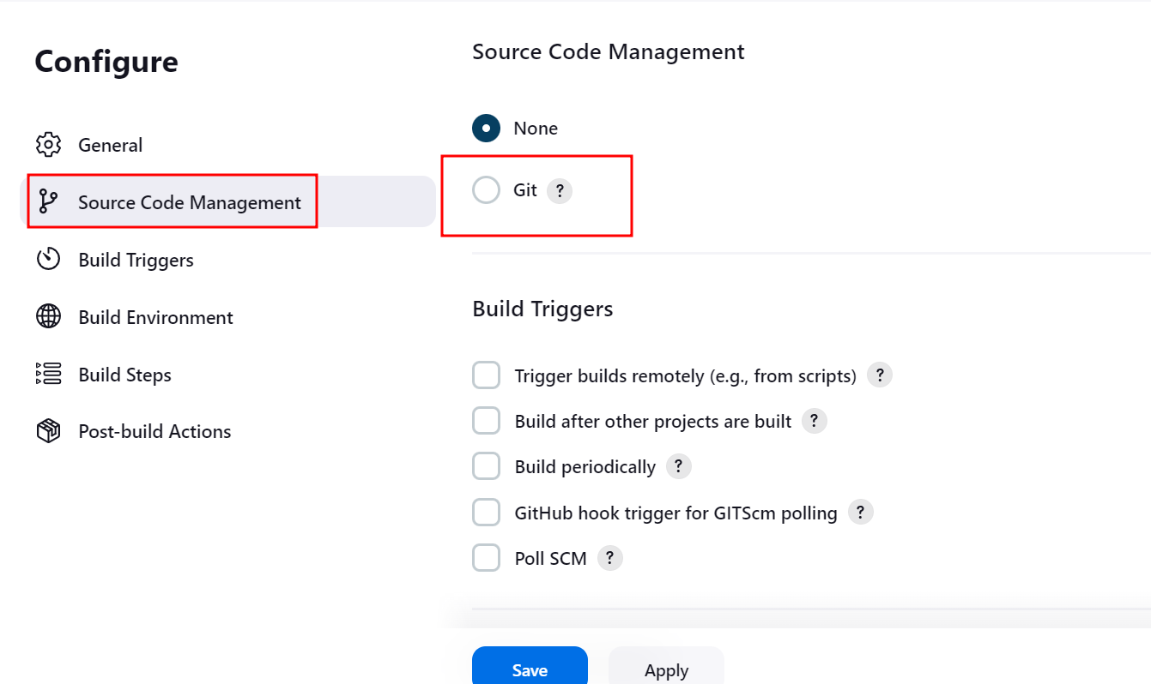

Please select git option

And write the repository as

<https://github.com/Kaleakash/docker-compose-repository.git>

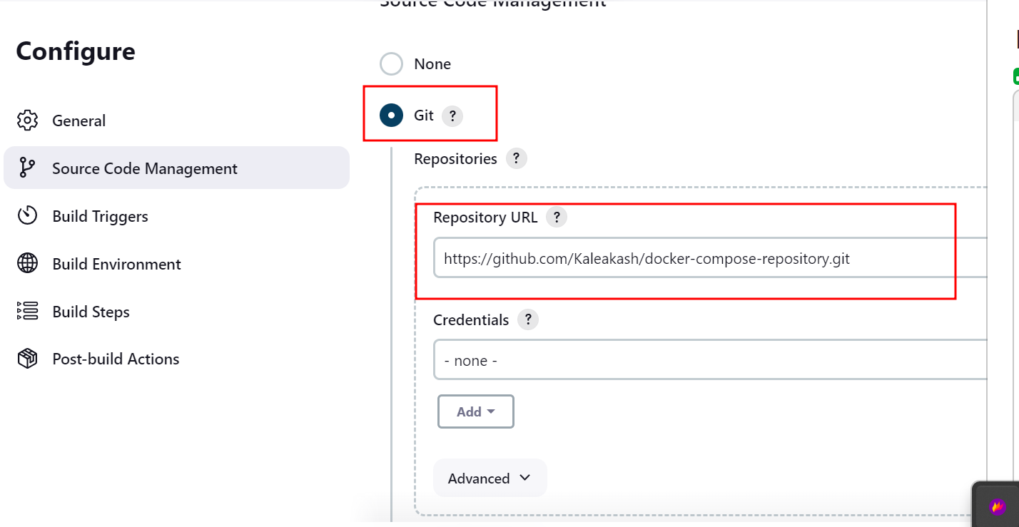

Then check the branch name must be same in git hub and in Jenkins

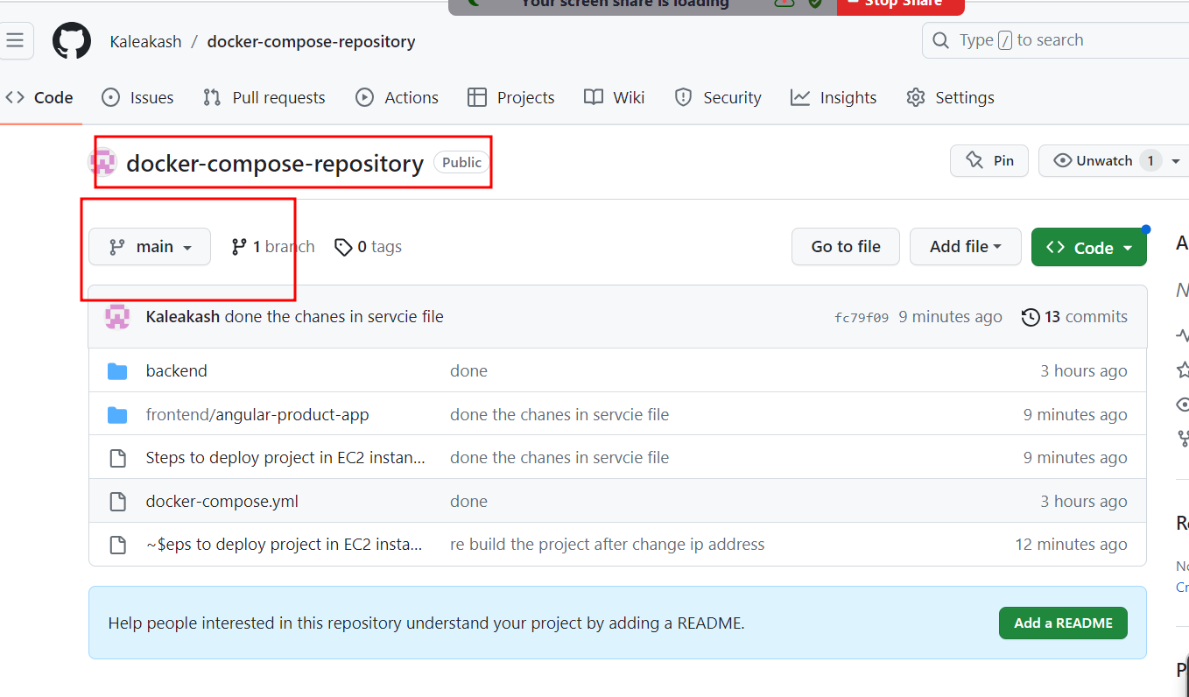

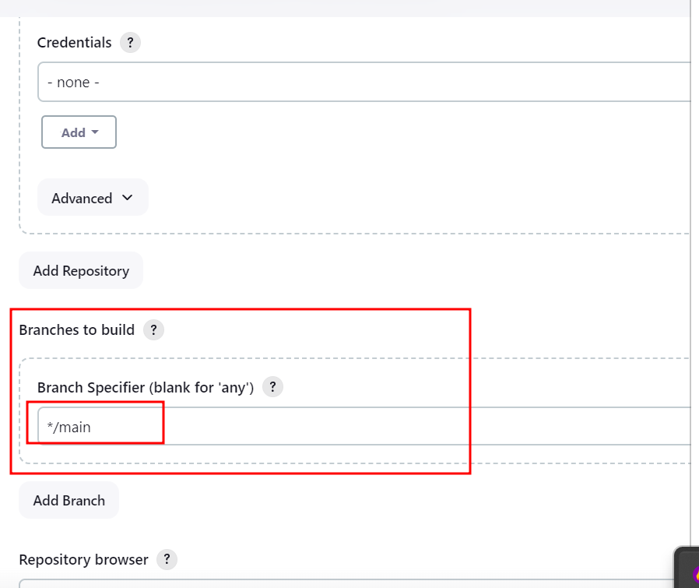

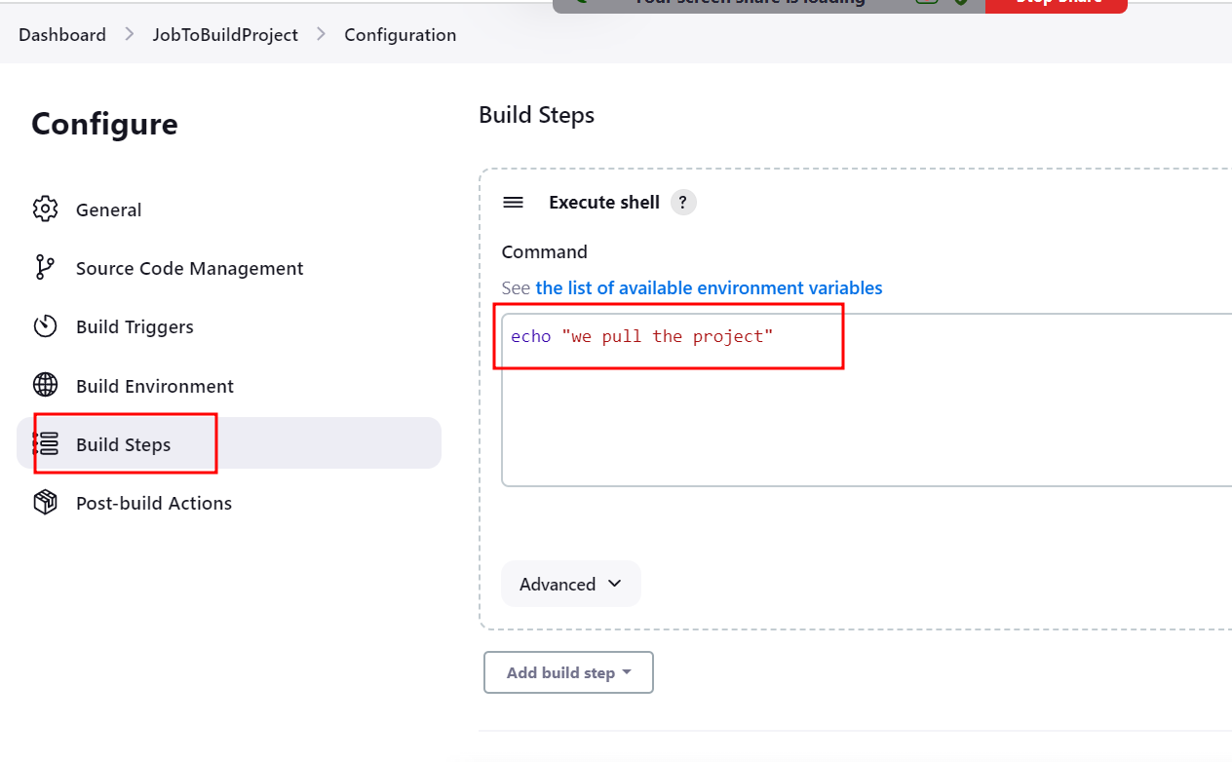

Now click on apply and save and build the project.

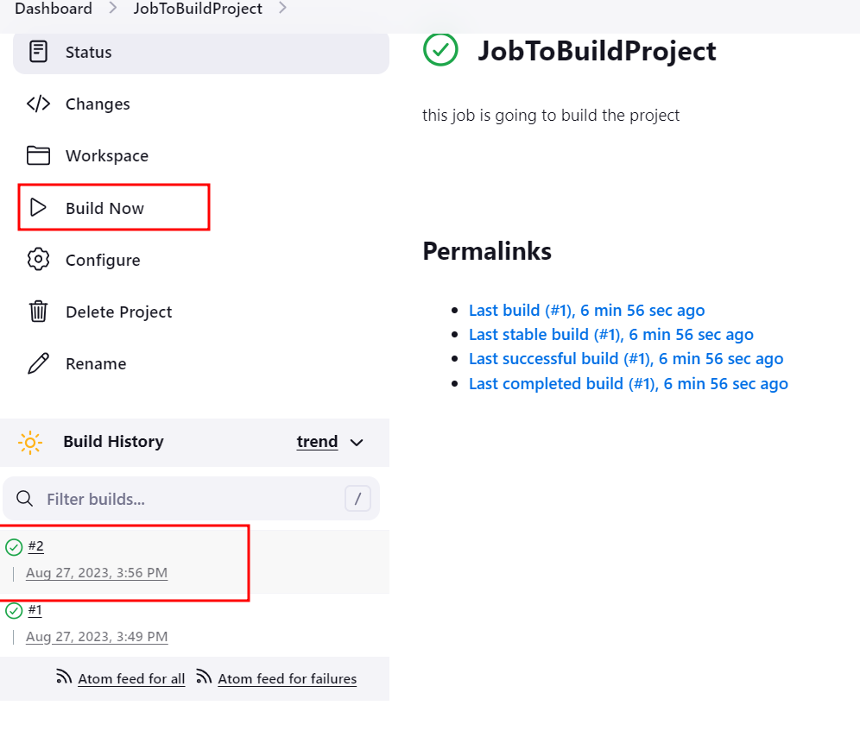

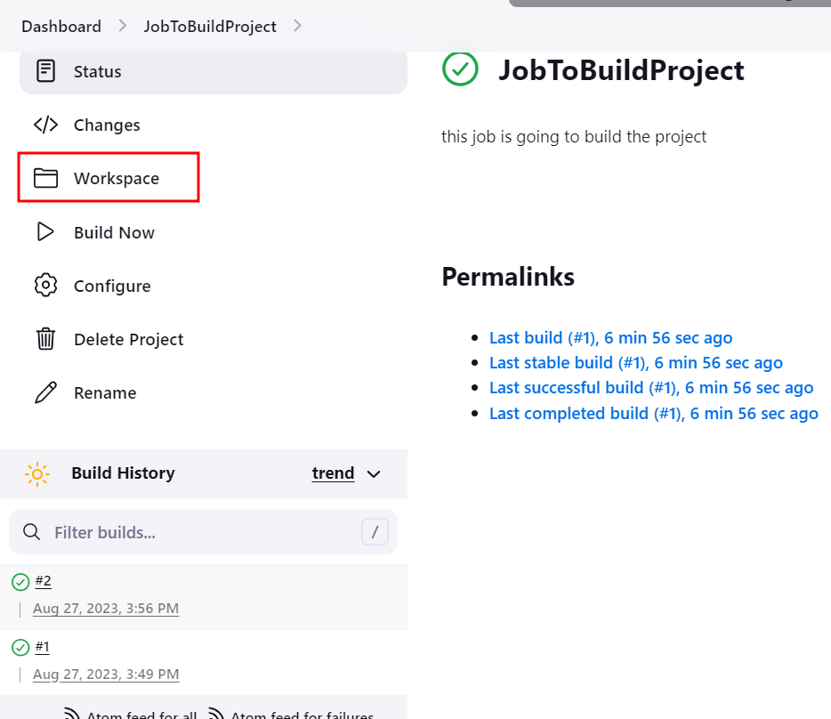

Please click on workspace to check project pull from git to Jenkin dashboard.

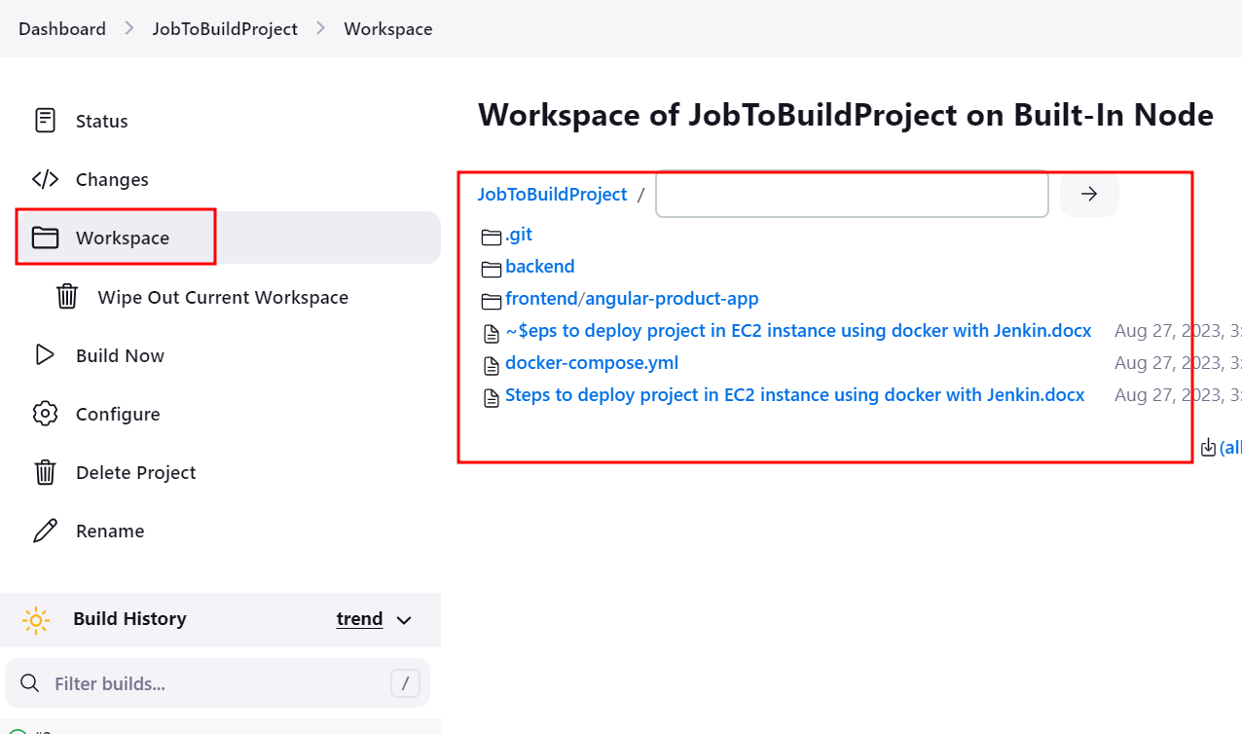

In we will run the docker-compose file to run three containers.

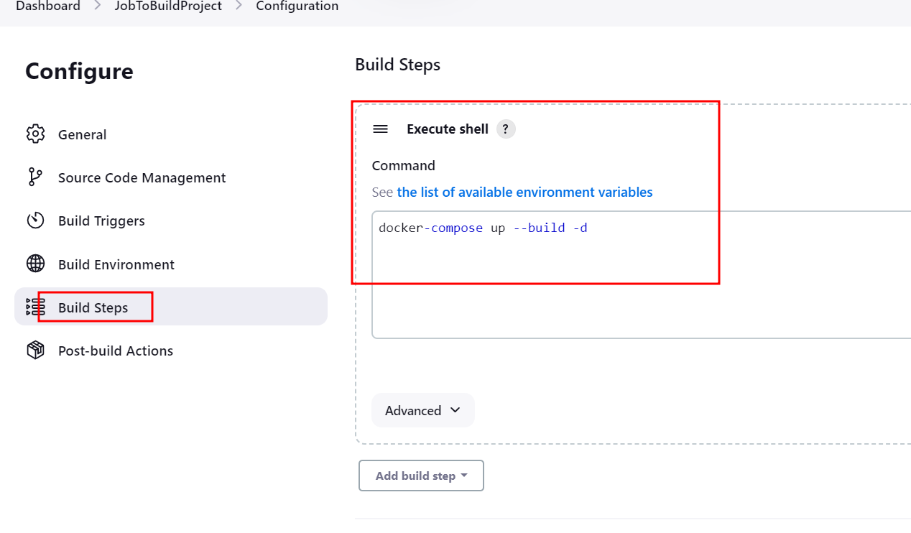

Here we are running docker-compose file to create images and run the container.

Save and apply and click build options.

